Toronto Library Finder

Android Final Project Report

By: Adith Syam and Pranoy Santosh

**Business Statement:**

Toronto Libraries is an app that allows the users of the app to browse a list of all the public libraries located in the City of Toronto. This application will use the GIS data that is provided by the City of Toronto, which contains the Name, address, hours of operation, phone number, etc. The main screen will provide the users with a list of all the library names in a scrollable view. The user can then choose one library which would open another screen which would provide the user with the address of the library, phone number and also the Hours of operation of that selected library. There will also be a search button which will allow the user to narrow down the results.

**Similar apps in the Google Play Store:**

Localmint - The Store Locator:

This app lets the user browse a list of different categories of stores and depending on what the user selects it shows the list of stores in that specific category also with the hours of operation. You may further select the specific store and it will show you a map with the location of the store and also other information about that store.

<https://play.google.com/store/apps/details?id=com.localmint.android&hl=en>

Store Locator:

This app lets you locate store and shopping centers across Belgium and Luxembourg. This application is also a very good example of how our app is going to work. It has similar functionalites compared to the app mentioned above, but the only restriction being it only shows shopping centers in Belgium and Luxembourg.

<https://play.google.com/store/apps/details?id=be.cushmanwakefield.storelocator&hl=en>

Our application uses similar features that the apps mentioned above provies. Our application will use data that is provided by the City of Toronto. This app will let users quickly find out informations about the libraries located in Toronto and also since the information about the libraries will be included in the application package the user doesn’t need internet to access the app. Thus making this application usable for all the users with an Android smartphone.

**Use-Cases**:

User opens the app → The system opens the app and provides the user with a list of all the libraries located in the City of Toronto.

User selects a specific library from the list → The system opens a new activity which would display the Address, Phone Number, and the Hours of Operation of the selected library.

User Selects the back button → The system will take the user back to the list of the libraries and then the user is free to choose any other library branch.

User taps the search button on top right → The system will display a list of libraries based on the search result.

**UI Content:**

All the back functions will use the default back button provided by Android OS. All the names/ branches of the libraries will be shown in a scrollable List View. There will be a search function which allows the user to narrow down the list of libraries.

**Error Handling:**

Any error that occurs will be displayed to the user in a form of a dialog box.

**Essential/Core features:**

The essential features of the app would be showing the list of the libraries to the user. The user will be allowed to select a specific branch of the library and it will display all the information about the library like the address, phone number and also the Hours of operation.

**Additional Features:**

Additional features would be showing a map with the location of the selected library.

**Testing:**

The application would be tested by both of us.

**Screenshots:**

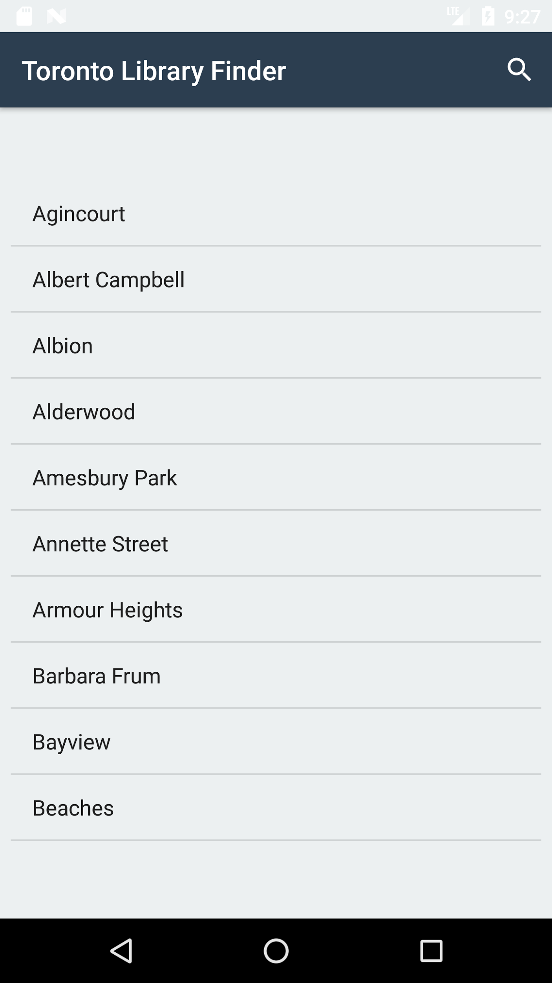

**LISTVIEW**

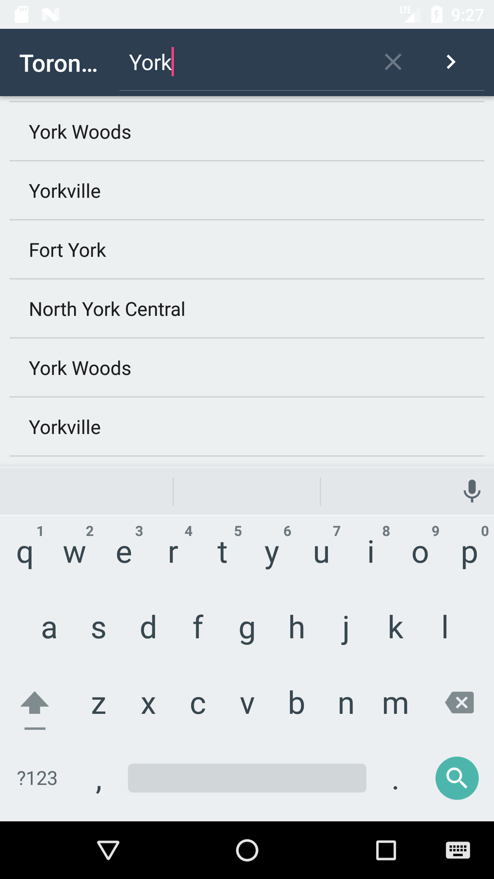

**Search**

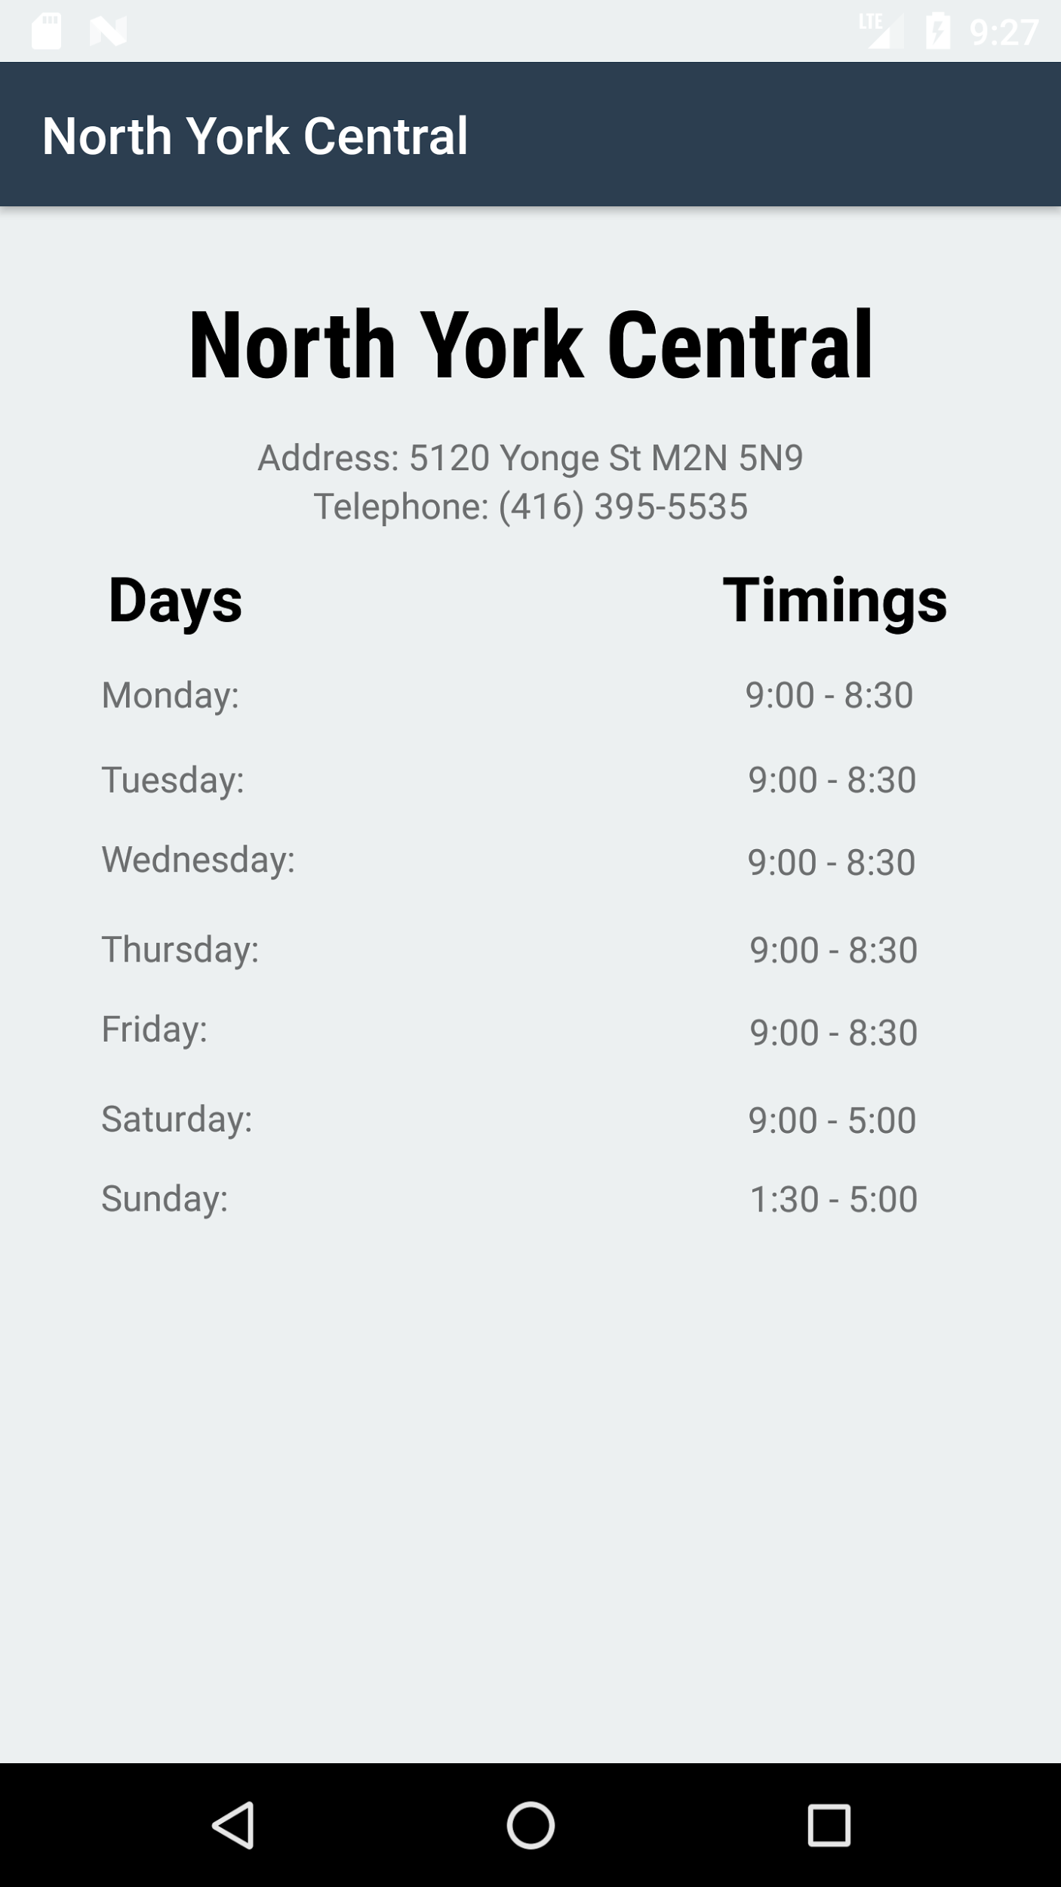

**options_selected**